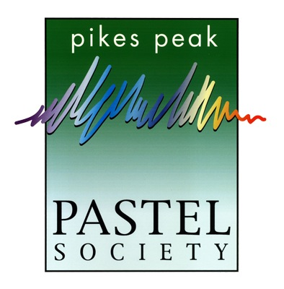
For Immediate Release
August 1, 2018

Pikes Peak Pastel Society presents
PASTEL JOURNEYS
Color Speaking to the Soul
September 12 – October 28, 2018
Library 21c, Colorado Springs

All are invited to the upcoming Pastel Journeys Exhibition at Library 21c in Colorado Springs, CO. This exhibition will run from September 12 – October 28, 2018, featuring original pastel paintings by the members of the Pikes Peak Pastel Society. The opening reception will be held on Thursday, September 13, from 4 – 6pm. Refreshments will be served.
The exhibition is free and open to the public. Original artwork will be available for purchase.

About Pastel
Pastel is pure pigment, the same pigment that is used in oil paints. When viewed under a microscope, pastel particles look like colorful, multi-faceted gems. These particles provide the medium with intense color and luminance. Pastel paintings are vibrant, with strong darks and brilliant color.
Paintings by Edgar Degas, Mary Cassatt, William Merritt Chase, Childe Hassam, Georgia O’Keefe and James McNeil Whistler featured pastels among their most important works. Today, pastel has the same stature as oil and watercolor. There are many styles and innovative approaches to pastel painting, ranging from traditional to contemporary.

Exhibition Details
The exhibition, sponsored by the Pikes Peak Pastel Society, will be held at Library 21c, 1175 Chapel Hills Drive, Colorado Springs, CO 80920. (Northwest corner of Chapel Hills Drive & Jamboree Drive)
Hours: Monday – Thursday: 9am - 9pm; Friday and Saturday: 10am - 6pm; Sunday: 1 - 5pm.
Please check the Library 21c website for holiday hours and closures.
Library 21c website: ppld.org/library-21c, or call: 719-884-9800
Pikes Peak Pastel Society website: pikespeakpastel.org
The Pikes Peak Pastel Society, founded in January 2000, has a current membership of 33, and is a member of the International Association of Pastel Societies.

Contact email: info@pikespeakpastel.org

Attached: “Just You and Me Now”, 12” x12” pastel over gouache on board, by Honey Lea Gaydos

